CIS1513_Using OBJECT BROWSER wizard to CREATE a TABLE instead of using SQL commands window.

The example below shows how to create the DEPARTMENTS_BJ table.

1. Click on SQL WORKSHOP – choose OBJECT BROWSER

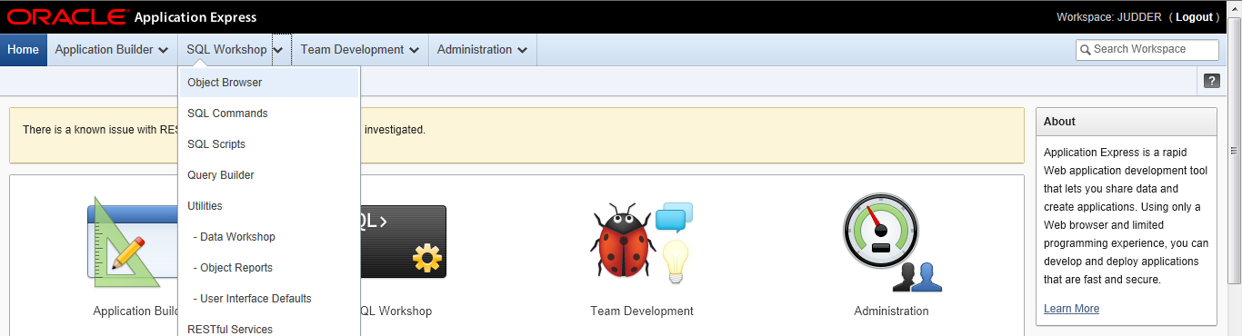

2. The object browser shows your tables scroll to far right & click on CREATE TABLE

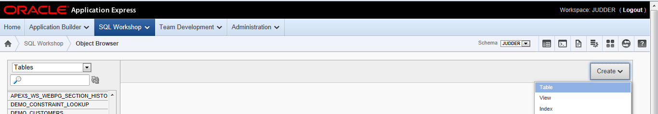

3. Fill out the Column Names and Data Types then click NEXT
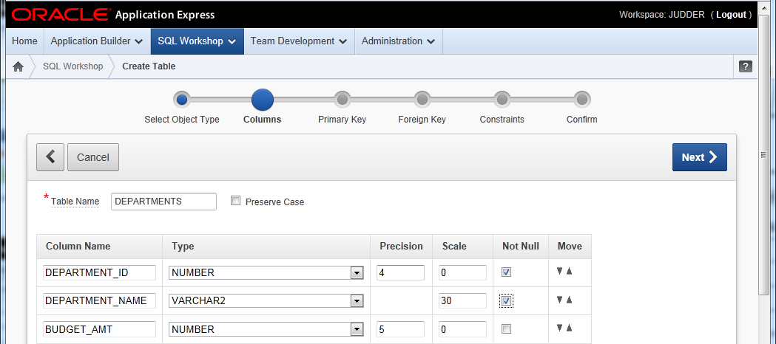

4. For the Primary Key click on NOT populated and Choose the DEPARTMENT_ID click NEXT

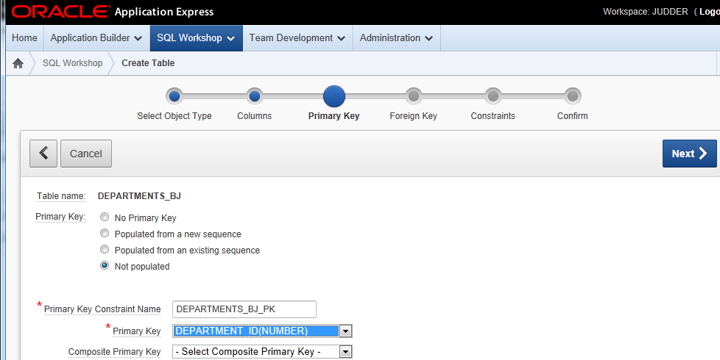

5. click NEXT there are no FK’s to define.

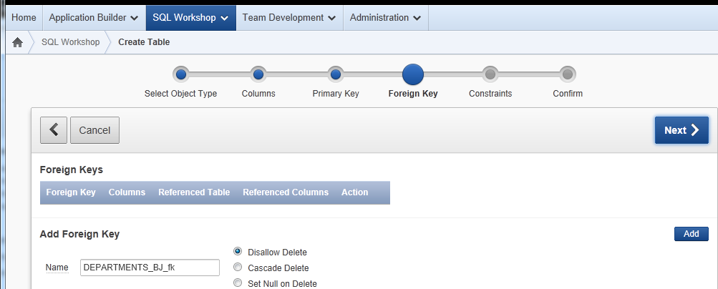

6. click NEXT there are no CHECK constraints to define.

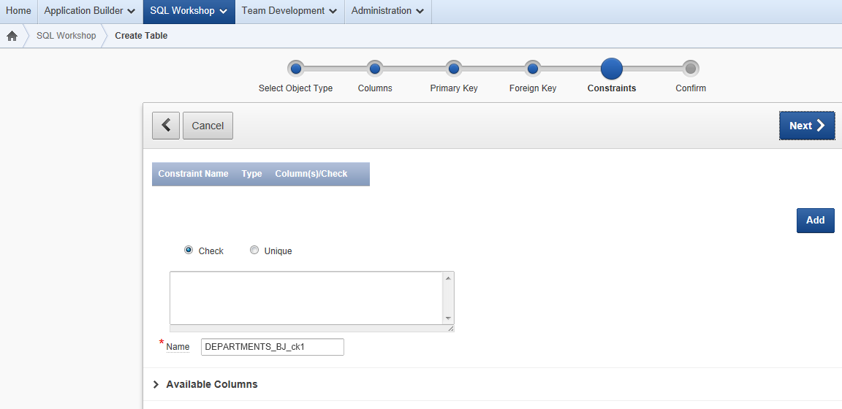

- This is the last screen before it will create the table,
CLICK on SQL tab below, (it will show the code that Oracle has built for you so you can learn the syntax)

Note: Oracle Puts Double Quotes “ “ around the table and column names – when you code in the sql command window you don’t need to use “ “ that is used to preserve the case.
CLICK on CREATE Table BUTTON at far left.
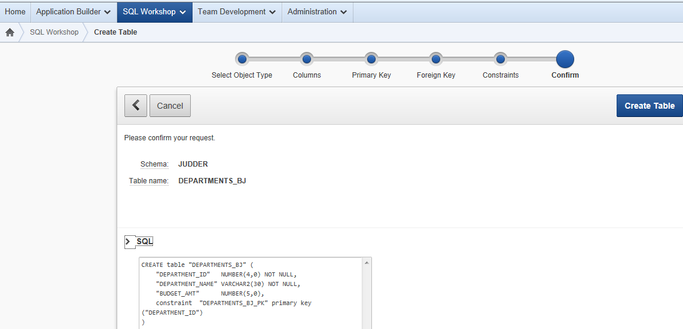

- The next window you will see will be OBJECT Browser showing your DEPARTMENTS table. Take a screen shot and attach to your homework.
NOTE: How to do a Screen Print (Press ALT + PRTSCR button (top of keyboard) then paste into a WORD or WORDPAD document. Save , Upload to blackboard, Submit.)

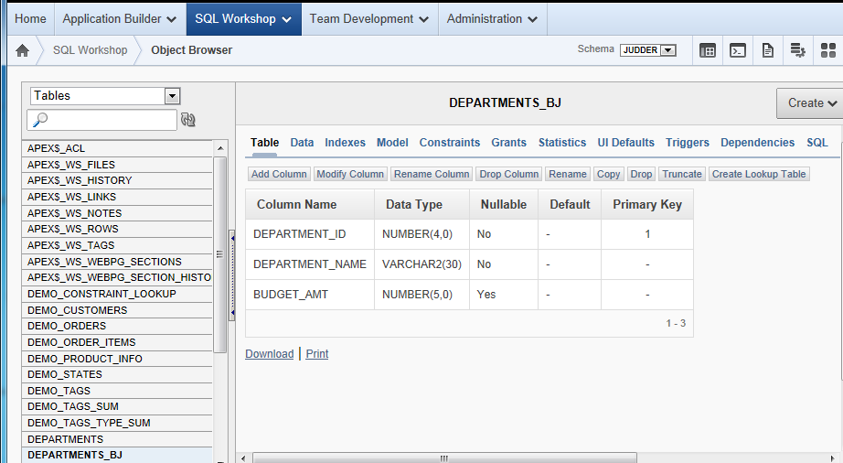s

